DEPARTMENT OF HEALTH SCIENCES
TMV, KOTI HYDERABAD.
1.Hands on Training Programm at S.L Diagnostic Centre:
We the department of Health Sciences took our students of DMLT and MLT of Telangana Mahila Vishwavidyalayam to S.L diagnostic centre for the hands on training programme of Medical Diagnostics as part of their course The Hands on Training programme was held at Windsor plaza nallakunta hyderabad from 27/02/2023 to 04/03/2023.

1.Practical exposure to all batches i.e DMLT 2nd year & BSC MLT 1st year & 2nd year in the field of :
> Clinical Biochemistry & Immunoassays
> Hematology & Clinical pathology
> Histopathology & Cytopathology
> Microbiology & Serology
> Molecular Diagnostics (PCR)
> Introduction of instrumentation in a Clinical Laboratory
Theorectical orientation of the techniques performed in a clinical laboratory by the eminent Medical College Doctors (Profesors ) and other junior doctors and PG Medical doctors and Well Trained technical staff of SL Diagnostics center.
2.Conducted internal practical exams for DMLT 2nd year (Pathology, Biochemistry & Microbiology)
3.Conducted Semester 1 practical exam for MLT 1st year (biochemistry, pathology)
4.For MLT 2nd year / Lateral entry students, core subjects practical examination are conducted for semester-3 i.e Histochemistry , Clinical Pathology & Microbiology
5.for MLT 2nd year students/lateral entry students, core subject practical examinations are conducted for Semester-1 i.e, physiology.
- Certificate were also awarded to all the students who are attended the training programme along with the teaching staff and the Director of S.L diagnostics Centre Dr. A.SUJATHA RANI.

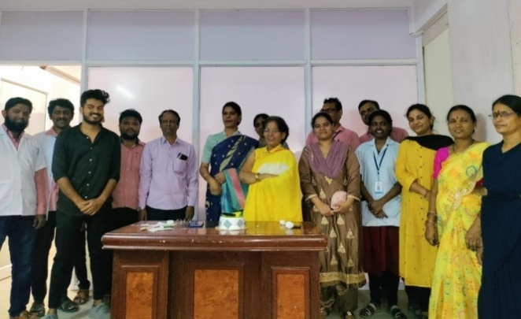
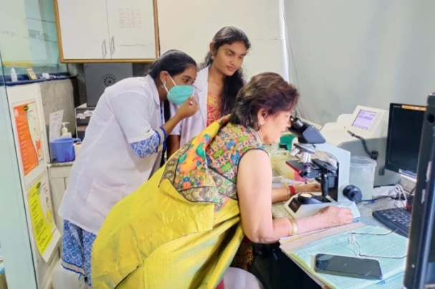
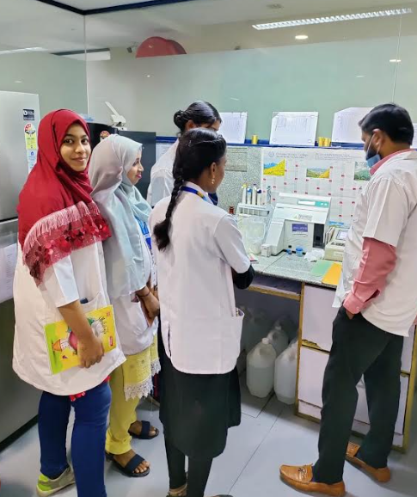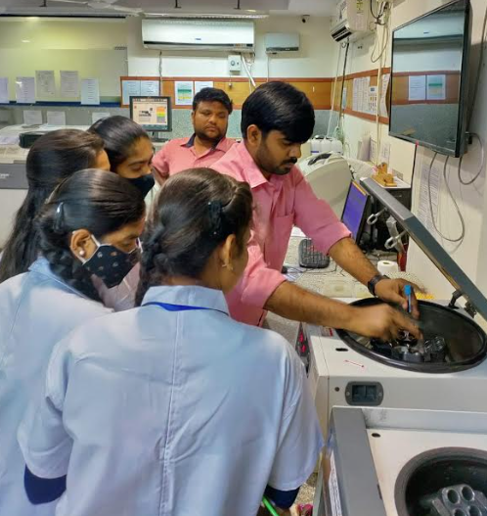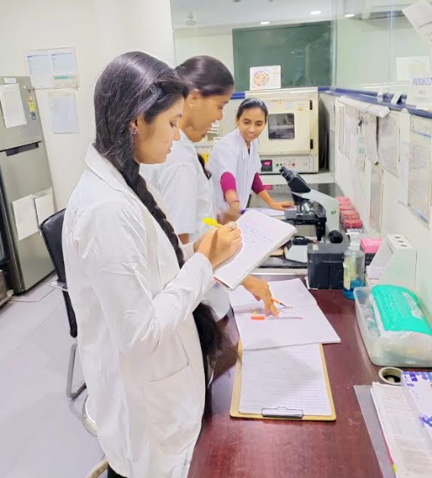
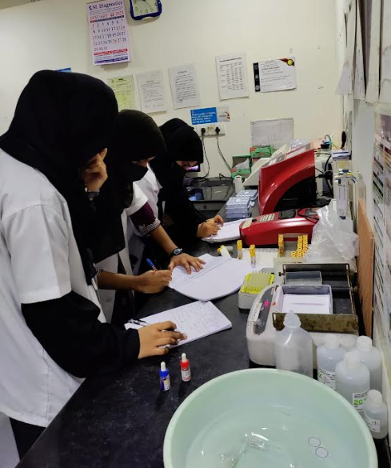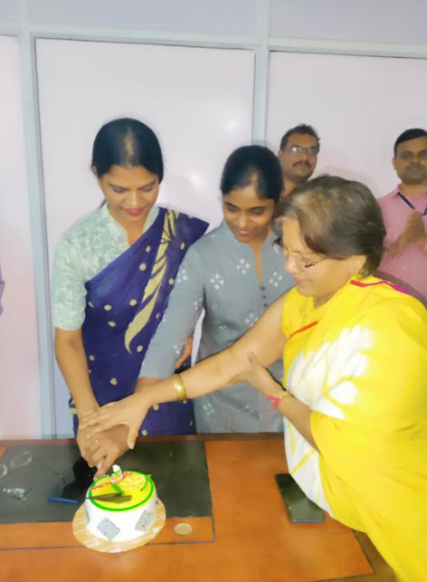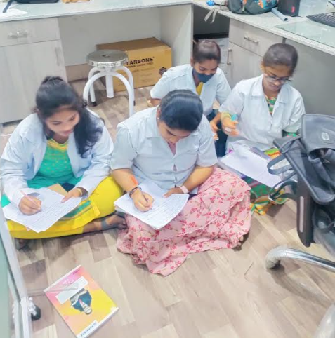

2.Hands on Training Programme On Diagnostic Malarial Microscopy and Filarial Microscopy at Regional office of Health and Family Welfare govt of India:
Telangana mahila Vishwavidyalayam students of Bsc MLT I year & Bsc MLT II year & DMLT 1st and 2nd year students has attended the Malaria and Filaria Diagnostic held at Regional Office of Health and Family welfare, Hyderabad which was held from 13/03/2023 to 16/03/2023.
Students were attended guest lectures by eminent doctors and wellversed Lab Technicians exposed to discussions on Malaria and Filarial diseases. during morning session and afternoon they took hands on training by technicians. Before the starting of the training programme they conducted a Pre-Test just to acces the knowledge of the students and they also conducted post training test to check the validity of their training programme. In that test our students of Mlt 2nd year Secured 100 percentage of marks they were felicitated by senior Director of ROHFW DR. ANURADHA MEDOJUE the Names of the students are
1.K.Sony
2.Soumya
3.Jeevana jyothi
4.Gayathri
Remaining students of MLT even they Secured 90 percentage Marks On successful completion of 4days training programme, valedictory ceremony was being conducted in the Campus of TMV with students and Teaching staff & Non teaching staff of Department of Health sciences and Doctors and Technicians of ROHFW and the students were awarded with Certificates by DR. ANURADHA MEDOJUE, ( Senior Regional Director ) ROHFW and chief of AP & TS, Govt. of INDIA.

